**Biographies of key exhibition creators**

**Creative Director, Richard Taylor**



With more than 27 years of film-making experience, five time Oscar® winner Richard Taylor is the co-founder of Weta Workshop and the Creative Director behind the exhibition alongside his team of artisans.

**Historical Director, Dr Christopher Pugsley**

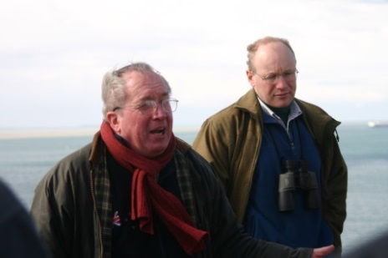

Historian Dr Christopher Pugsley is regarded as one of New Zealand’s foremost authorities on the First World War and the Gallipoli Campaign in particular. He was made an Officer of the New Zealand Order of Merit in recognition of his services as a military historian in 2014.

**Lead Curator, Kirstie Ross**



Kirstie has 16 years’ experience working in New Zealand history and heritage. For the last eight years she has been researching the visual and material culture of the New Zealand home front during the First World War as well as other aspects of the war. Kirstie has published books including *Holding on to Home: New Zealand Stories and Objects of the First World War* (2014).

**Lead designer, Benjamin Barraud**

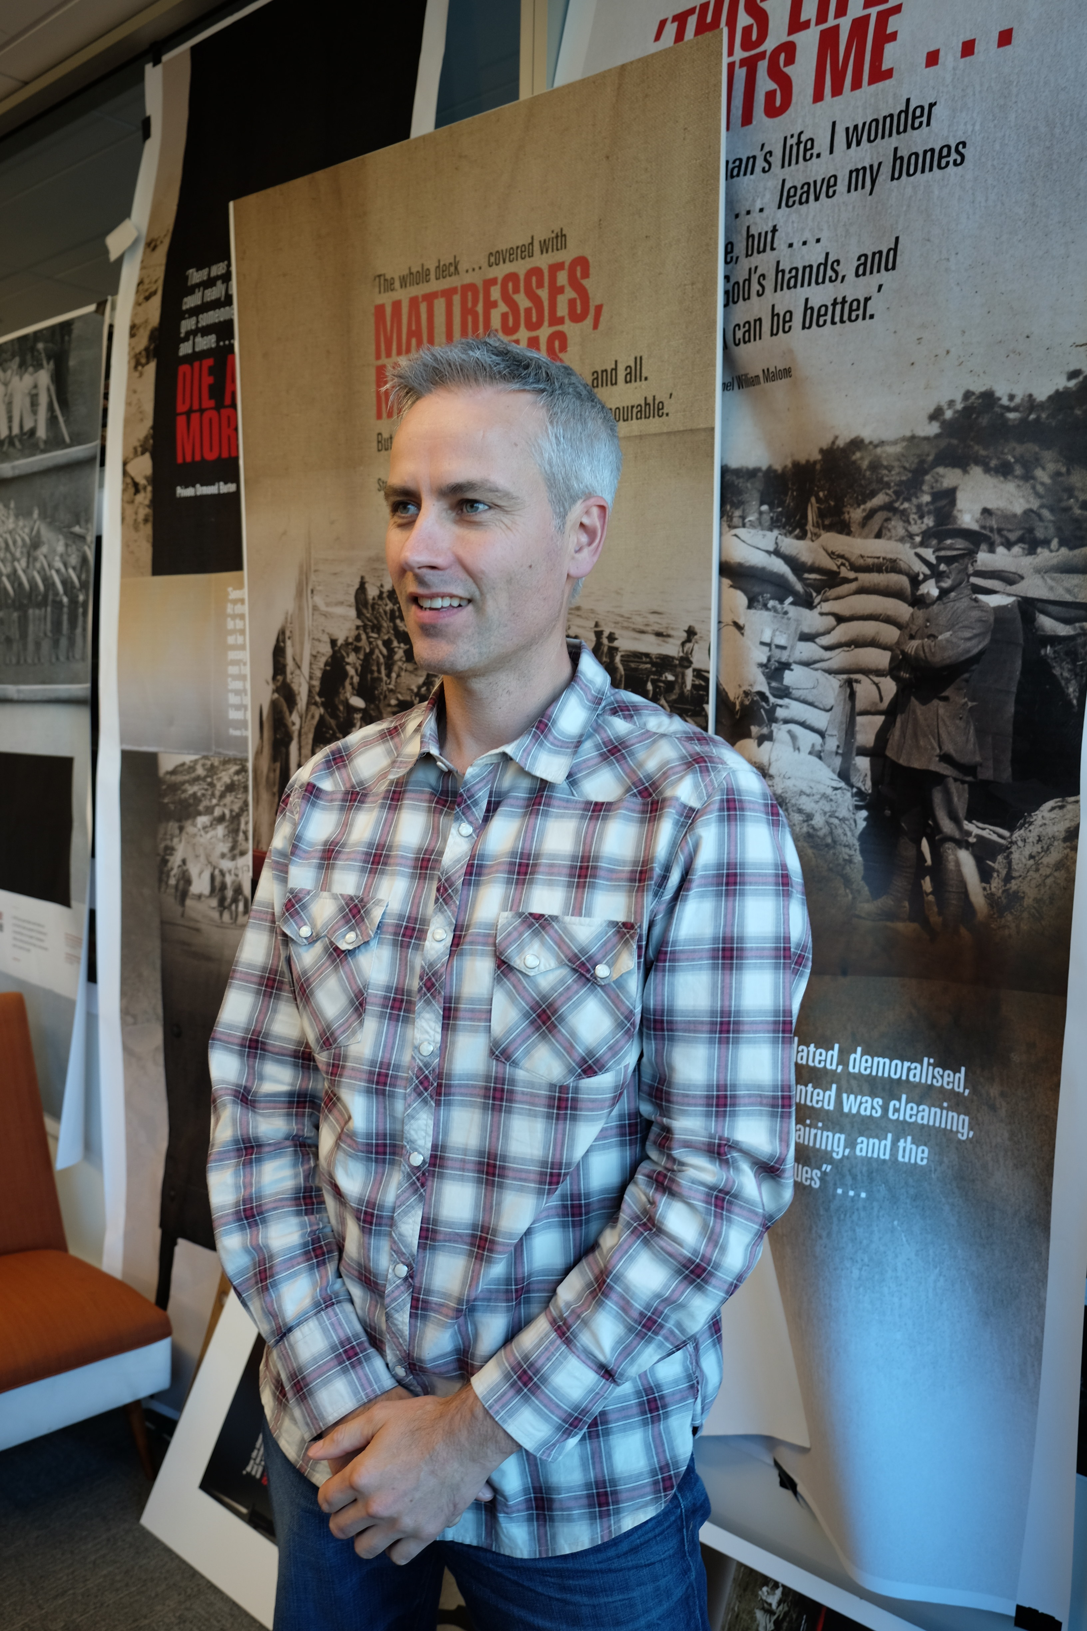Benjamin Barraud is a multi-disciplined designer that brings more than 20 years of art direction experience to the exhibition design.

**Soundscape and sound design, Composer Tane Upjohn-Beatson**

Tane is an award winning New Zealand composer and sound designer who is responsible for composing the soundscape and score for the exhibition.

**Writers:** Frith Williams, James Brown and Rupert Alchin

**Gallipoli multimedia producer:** Prue Donald

**Graphic designer:** Nick Clarkson

**Gallipoli exhibition curators:** Michael Fitzgerald, Amber Aranui, Stephanie Gibson, Puawai Cairns

**Audience engagement facilitator:** Lucy Moore