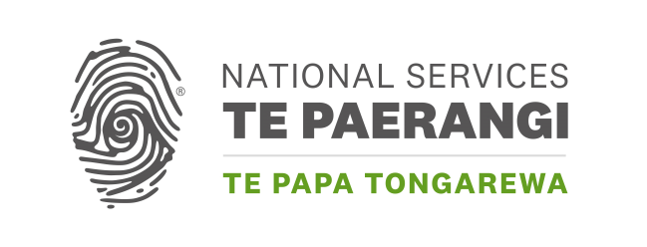

**Ngākahu Ruruhau | National Repatriation Fund**

**Application form**

Ngākahu Ruruhau provides access to expert assistance and practical support for projects that progress the repatriation of human remains from collections held in Aotearoa New Zealand museums and collecting institutions.

**What is the name of your organisation?**

Click or tap here to enter text.

**Total amount requested (up to $7,000 incl. GST):**

Click or tap here to enter text.

**Summary of your need including identified costs**

*i.e. Identified expert and proposed statement of work, transport quotes, materials for care of taonga*

Click or tap here to enter text.

**How have you identified your need?**

*i.e. Report / review of ancestral remains in care, consultation with iwi…*

Click or tap here to enter text.

**Why is this a priority for your organisation?**

Click or tap here to enter text.

**Proposed project date:** Click or tap here to enter text.

**Contact person** **regarding this application**

|  |  |
| --- | --- |
| Name: | Click or tap here to enter text. |
| Position: | Click or tap here to enter text. |
| Phone (daytime): | Click or tap here to enter text. |
| Phone (evening): | Click or tap here to enter text. |
| Address: | Click or tap here to enter text. |
| Email: | Click or tap here to enter text. |

**Checklist**

The following information must accompany this application:

1. Evidence of costs (quotes from suppliers, cost estimates etc)

2. A copy of your most recent bank statement

3. Evidence of your legal status (a letter of incorporation, evidence of

charitable trust status etc)

4. If applicable, a copy of your letter from Inland Revenue confirming Tax Exempt status

**Please email your application to:**

[NSTPGrants@tepapa.govt.nz](mailto:NSTPGrants@tepapa.govt.nz)

**Please don’t email your application to a particular staff member. (In the absence of the named staff member, your application would be delayed.)**