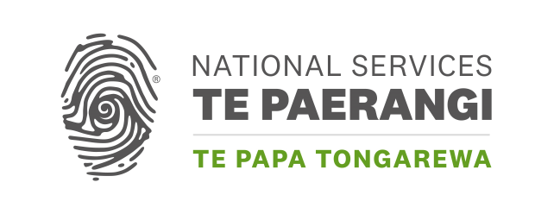

Ngākahu Ruruhau | National Repatriation Fund
Application form
Ngākahu Ruruhau provides funding to organisations in Aotearoa New Zealand for projects that support the repatriation of ancestral remains and taonga Māori from museums, collecting institutions, and other organisations in Aotearoa New Zealand and overseas.

What is the name of your organisation?
Click or tap here to enter text.

Total amount requested (up to $5,000 incl. GST):
Click or tap here to enter text.

Summary of your need including identified costs
i.e. Identified expert and proposed statement of work, transport quotes, materials for care of taonga
Click or tap here to enter text.

How have you identified your need?
i.e. Report / review of ancestral remains in care, consultation with iwi…
Click or tap here to enter text.

Proposed project date (your project must be completed by 30 June of the financial year in which you apply):
Click or tap here to enter text.

Contact person regarding this application
Name: | Click or tap here to enter text.
Position: | Click or tap here to enter text.
Phone: | Click or tap here to enter text.
Address: | Click or tap here to enter text.
Email: | Click or tap here to enter text.

Checklist
The following information must accompany this application:
☐ 1. Evidence of costs (quote or invoice from supplier)
☐ 2. Most recent annual accounts
☐ 3. Most recent bank statement
☐ 4. Evidence of legal status (a letter of incorporation, evidence of
charitable trust status, etc)
☐ 5. If applicable, a copy of your letter from Inland Revenue confirming Tax Exempt status

Please email your application to:
NSTPGrants@tepapa.govt.nz

Please don’t email your application to a particular staff member. (In the absence of the named staff member, your application would be delayed.)

